Proceedings Report

A National Symposium | “Moving Forward by Working Together”

October 17th – October 18th, 2019
Hyatt Regency Clearwater Beach
Clearwater, Florida
ACRONYMS USED IN THE REPORT

ACE Adverse Childhood Experiences
ESEA Elementary and Secondary Education Act
ESSA Every Student Succeeds Act of 2015
H-2A A Federal program allowing U.S. employers to bring foreign nationals to the U.S. to fill temporary agricultural jobs
GPRA Government and Performance Results Act
ICE Immigration and Customs Enforcement
ID&R Identification and Recruitment
IMEC Interstate Migrant Education Council
LEA Local Education Agency
MEP Migrant Education Program
MSIX Migrant Student Information Exchange
OME Office of Migrant Education
OSY Out-of-School Youth
PAC Parent Advisory Council
SEA State Education Agency
SEL Social Emotional Learning
STEM Science, Technology, Engineering, and Mathematics
STEAM Science, Technology, Engineering, Art, and Mathematics

ACknowleDgements

The Interstate Migrant Education Council (IMEC) wishes to acknowledge the following individuals and agencies that have generously contributed their time and resources to making the national symposium “Moving Forward by Working Together”, a success.
- Facilitators: Lead Facilitators: Jonathan Fernow (Oregon); Tomas Mejia (Colorado); and Brad Whitman (Pennsylvania); Table Facilitators: Kul Axtell (Nevada); Susanna Bartee (Kansas); Valerie Beard (Indiana); Jessica Castaneda (Tennessee); Sue Henry (Nebraska); Emily Hoffman (Massachusetts); Tracie Kalic (Kansas); Carmen Medina (Pennsylvania); Ray Melecio (ESCORT); Will Messier (New York); Barbie Patch (New Hampshire); Jose Salinas (Ohio); Mike Toole (Kansas); Nathan Williamson (Indiana)
- IMEC Membership, Chair: Jonathan Fernow (Oregon)
- Kansas Migrant Education Program, Doug Boline, Director and Dr. John Farrell, Special Projects Director
- ESCORT, - Oneonta, New York - Ray Melecio, Director
- John Fink, Atlanta, Georgia, (Program design)
- Susanna Bartee and Tracie Kalic (Producing the printed program)
- Planning Committee comprised of Dr. John Farrell; Tomas Mejia; Brad Whitman; Valerie Beard; John Fink; Solomon Kaulukukui; Jonathan Fernow; Francisco Garcia; and Nancy Wiehe
- Presenters: Ruth Ryder (Deputy Assistant Secretary, Office of Formula Grants, Office of Elementary and Secondary Education); Dr. Richard Stup (Cornell University); Joanne Bogart (Office of Policy Studies, U.S. Department of Education); Lisa Gillette and Sarah Martinez (Director and Policy Lead, Office of Migrant Education, U.S. Department of Education); Dr. Jim Rollins (Superintendent, Springdale School District, Springdale, Arkansas); Dr. Rosemary Hughes (Director, Bureau of School Support, Pennsylvania Department of Education); Francisco Garcia (Executive Director, Interstate Migrant Education Council); Interstate Migrant Education Council Members: Carmen Medina (Pennsylvania); Jose Salinas (Ohio); Brad Whitman (Pennsylvania) and Sue Henry (Nebraska)
- Videography: Mark Dodge (Eudora USD #491; Kansas)
- Homestead-Miami Mariachi Conservatory

This Proceedings document was prepared for IMEC by Solomon Kaulukukui, Independent Consultant, January, 2020
TABLE OF CONTENTS

Acronyms Used in the Report
I. Executive Summary 1
II. Introduction 5
About the Interstate Migrant Education Council 5
Purpose of the Symposium and the Proceedings Document 5
Symposium Agenda 6
Organization of the Symposium Proceedings Document 7
III. Summary of Discussion from Core Presentations ……………………...8
“Agricultural Workforce Outlook: How Demographics, Technology, and Markets are Transforming Farm Labor” (Dr. Richard Stup) ………………………………………….8
“Federal, State and Local Perspectives Regarding Findings from the Study of the Implementation of the ESEA Title I, (Part C) – Migrant Education Program”
(Joanne Bogart) …………………………………………………………………………11
IV. Conclusions and Recommendations 14
V. Follow-up to the Symposium 18
VI. Appendices 19
Appendix A – Symposium Contact Info ………………………………………………...20
Appendix B – Symposium Agenda ……………………………………………………...21
Appendix C – Symposium Summary from the Work Groups ....................…………......24
Appendix D – Summary of Evaluations …………………………...……………………30

Executive Summary

The Interstate Migrant Education Council (IMEC) sponsored their third national symposium, “Moving Forward by Working Together”, on October 17-18, 2019 in Clearwater, Florida. A total of 116 participants attended this symposium with the participants representing 38 states across the nation including the District of Columbia. Many participants stated that prior to attending the symposium their desired outcome was to learn new things that can help them with their job and their migrant program as well as the participants were also looking forward to the time to network/collaborate with their peers and colleagues. The symposium met almost all of the participants’ desired outcomes through the presentations and interactions among national, state and local education agency personnel; legislators; state school board members; university collaborators; and other Migrant Education Program (MEP) stakeholders. The topics presented and discussed were in the areas of research, data analysis, promising practices, and engaging information that will help to benefit the migrant program and the families and students that are served.
The Migrant Education Program (MEP) is a federally funded program, authorized under the Elementary and Secondary Education Act of 1965 (ESEA), as amended by the Every Student Succeeds Act (ESSA) as Title I, Part C – Education of Migratory Children. The purpose of the program is:
- To assist States in supporting high-quality and comprehensive educational programs and services during the school year and, as applicable, during summer or intersession periods, that address the unique educational needs of migratory children.
- To ensure that migratory children who move among the States are not penalized in any manner by disparities among the States in curriculum, graduation requirements, and challenging State academic standards.
- To ensure that migratory children receive full and appropriate opportunities to meet the same challenging State academic standards that all children are expected to meet.
- To help migratory children overcome educational disruption, cultural and language barriers, social isolation, various health-related problems, and other factors that inhibit the ability of such children to succeed in school.
- To help migratory children benefit from State and local systemic reforms.
State education agencies (SEAs) are allocated Federal funds by a formula based on each state’s per pupil expenditure for education and counts of eligible migratory children, age 3 through 21, residing within the state.
There were several conclusions that have come out of this symposium based on the core presentations and the work group discussions. The impact of these conclusions on the future of the migrant education program moving forward will depend on how the recommendations from this report is carried out at the national, state, and local levels. The conclusions that emerged is centered around three areas.
- Shortage of Labor Workers vs. Mechanization
  - Several occurrences have caused a decrease in the work population. Unemployment rates are low with more Americans working as well as over the past decade, unauthorized immigration caused for a decrease in the work population. However, this is not the only reasons for a shortage of workers according to Dr. Stup’s presentation. Fewer young Mexicans are looking for work which is tied to the nation’s decline in the fertility rate. More are staying in Mexico, including women, to work. Guatemala’s data is still growing but not as pronounced as Mexico.
  - Due to a shortage in labor workers, farms still need to have their crops picked. Farms are looking at alternative ways to grow their crops which makes it easier to pick with machines. This is a high capital investment to replant trees to create crops to be picked by robots but the labor shortages will escalate the investment in technology. Thus, heavy manual and repetitive labor will be largely replaced by automation.
  - Climate change is affecting states in a very negative way. The change in the weather patterns is affecting the ability for migrant workers to find and keep work. Recent tariffs and trade wars have affected farms too as well this summer.

- The MEP Program Moving Forward
  - Although all states are using MSIX and submitting data into this system, the MSIX system is not being used to its fullest capacity. States are struggling to find personnel and time to maintain their data collection to feed into MSIX.
  - States would like to see the student’s eligibility for services by the MEP program moved from 3 years to 6 years. As a supplemental program, it is hard to measure student achievement if students are settling out early than later. Resources and interventions to meet the needs of the students and their families takes time to make a difference. Mobility of families will always be an issue if families do not settle out.
  - Creative ways need to be looked at in utilizing the migrant funds and the resources in order to meet the needs of the migrant families. Collaboration with other agencies that also provided support were some of the suggestions. Equitable services and issues like mental and emotional health are new challenges that the migrant programs are facing.
  - How ID&R was done in the past has now changed due to the changes in the agricultural field. Farms are having to use more H-2A and OSY workers to make up for the shortage in the work force. State and local levels are having to relook at how they are doing ID&R so that they can be more effective and how they can do it differently. More time and money are being spent to focus in on the ID&R efforts by hiring more staff to find the families. The MEP program is a supplemental program whose resources may be limited in meeting the needs of the migrant children and their families.

- What Have We Learned from ESSA So Far?
  - The GPRA indicators are linked to student achievement, yet the migrant program is supplemental in nature. Are there other ways to evaluate the effectiveness of the MEP program other than using state content assessments? Parent involvement has always been a part of the MEP program. How can programs get more parents involved in their child’s education?
  - Migrant students and their families truly have some unique needs. However, there is little research on what educators can do to meet these needs. Besides academic needs, issues such as equitable services and mental and emotional health are now surfacing as needs for the migrant families.
  - The terms “migrant”, “immigrant”, and “migratory” is causing confusion among practitioners who are not part of a migrant education program. Eligible families do not want to be associated with either one of the groups for fear of any possible retribution that has occurred to others in the past. ICE raids are also having an effect on families. The trust issue becomes a major hurdle to overcome for the migrant program as they try and work with the families they are trying to serve.
The recommendations are also clustered into the same three categories which are offered for consideration and implementation by local schools and school districts, SEA’s, OME, and other MEP decision makers and policymakers.
- Shortage of Labor Workers vs. Mechanization
  - Mexico may no longer be the main country where agriculture workers are coming from. Farms may have to look at growth areas such as Africa, Asia, and Central and South America as a population to be tapped.
  - Take a look at the 2017 Agricultural Census to see a significant reduction in workforce for agriculture and the farms that are affected not only nationally, but at the state and local level.
  - Employers need to recruit from all walks of life (rural-urban, native-immigrant) to find careers that combine biology, technology, and information. Could also be a part of the school’s STEAM program. Ensure that migrant children receive the same opportunities in these STEAM programs as their non-migrant peers receive.
  - Although climate change is out of our control, policy makers should look at ways to support farms (especially small ones) who are affected by not only the change in the climate but by the tariffs and trade wars that prevents them from raising and selling their products.

- The MEP Program Moving Forward
  - More training is needed on how to optimize the use of MSIX at both the local and state level. Maybe training should be done based on the size of states as smaller states needs will be different from that of a larger or middle size state.
  - Continue the discussion with policy makers and OME on increasing the eligibility status in the program from 3 years to 6 years.
  - Professional development should continue to be built in at the national, state, and local levels to share with practitioners on how to address the unique needs of the migrant students and their families. Networking time at all levels between states as well as between districts on how to best maximize the use of migrant funds with programs of similar needs and structure.
  - Find ways to leverage your agricultural data that will help to support your ID&R efforts.
  - Look at the impact that the H-2A program is having at the state and local level. Focus on OSY workers who may be eligible for the migrant education program in addition to the K-12 students.
  - Collaborate with other national, state, and local agencies who also work with the migrant population that your program serves to provide additional resources to the families.

- What Have We Learned from ESSA So Far?
  - A think tank group should be formed to talk about the issues mentioned in this report and how the Title I, Part C program can continue to move forward under ESSA and the changing times that are happening across our nation. The group would be composed of a cross section of participants similar to the makeup of the IMEC organization. Also included in the discussion is members from OME and policy makers at the national level. Recommendations would come from this group to be shared with OME and with policy makers as ESEA goes into its next reauthorization period.
  - Allow states more flexibility in the use of their migrant funds to address the unique needs of the migrant population.
  - Encourage collaboration at all levels and among all federal programs who provide services to the migrant population. Pool resources to meet the unique needs of these families.
  - Continue to educate those outside of the migrant education program on how the program defines a “migrant” worker and/or family.
  - Build trust with the families and how the program can benefit them and not have a negative label placed on them by their participation in the program.
  - As much as possible, use the word “migratory” in talking about the families that are served by this program.
To summarize all of what has been presented, the question becomes, “Where do we go from here?”. This Proceedings report is based on the core presentations, the work group discussions, and the evaluation feedbacks. The IMEC membership will need to look at recommendations that came out of this symposium and see how it fits to IMEC’s Strategic Plan. Through their strategic plan, IMEC can continue to play a leadership role in advocating and gathering information to aid policy makers as requested.

Introduction

About the Interstate Migrant Education Council
The Interstate Migrant Education Council (IMEC) was established in 1983 whose mission is to advocate for the highest quality education and other needed support for the nation’s migratory children and youth. IMEC’s members are state-level decision makers who examine MEP policy issues to ensure that the federal governance of the migrant program provides maximum flexibility to states to serve students and to recommend that specific programs be enhanced to improve migrant students’ academic achievement.

Currently, there are 23 member states: Alaska, Arizona, Arkansas, California, Colorado, Hawaii, Idaho, Illinois, Indiana, Kansas, Massachusetts, Nebraska, Nevada, New Jersey, New Mexico, New York, North Dakota, Ohio, Oregon, Pennsylvania, South Carolina, Utah, and Washington.

Purpose of the Symposium and the Proceedings Document
The theme for this year’s symposium is “Moving Forward by Working Together”. This is the 3rd National Symposium that the IMEC Council has hosted. Previous symposiums focused on “Changing Demographics and Mobility: New Opportunities in Migrant Education” (2015) and “The ABC’s of Education: Moving Forward Under ESSA to Engage the Agriculture, Business, and Education Communities” (2017). The planning committee felt that the previous two symposiums addressed issues that impacted the number of eligible migrant students (2015) and the impact of the implementation of the new Every Student Succeed Act (ESSA) on the Title I – Part C program (2017). With the increase in the mechanism and technology advances transforming the world of migrant education, this year’s symposium looked at how all levels (local, state, national) can work together in a coordinated effort to advance support services for migrant students and their families moving forward.

Core presentations on national trends and data helped to format discussion questions that participants had a chance to share their thoughts and ideas in a work group format. The work group sessions were facilitated by room and table monitors who were able to record the information which is shared in Appendix C of this document. Updated information on the Title I – Part C (Education of Migratory Children) was shared by the staff from the U.S. Department of Education – Migrant Education Program and by the Deputy Assistant Secretary, Office of Formula Grants, Office of Elementary and Secondary Education. Best practices ideas were shared by a panel representing the national, state, and local perspectives as well as responses from a few IMEC members. Conclusions and recommendations that were summarized in this document are presented to assist the MEP to design and provide the best possible services for migrant children and youth.
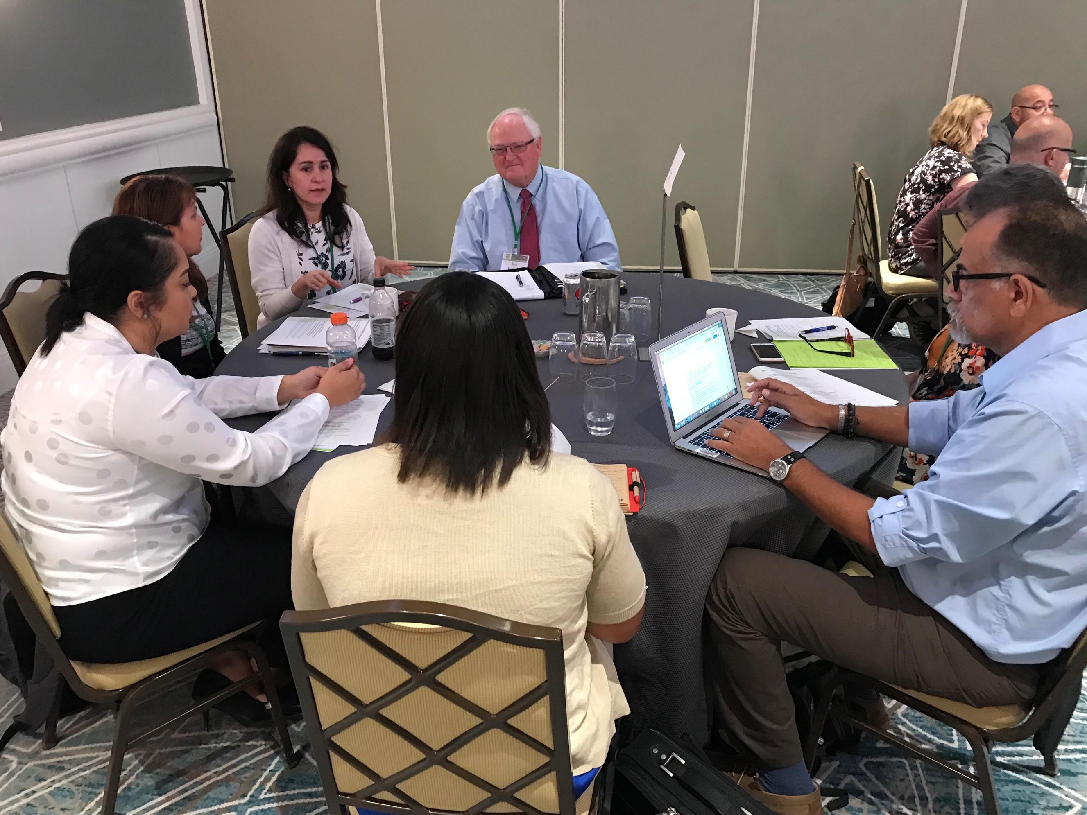
Work Group Session

Symposium Agenda
The first day of the symposium began with Mr. Jonathan Fernow, MEP Director from Oregon and the IMEC chair, welcoming everybody to the meeting. He introduced Ms. Ruth Ryder who is the Deputy Assistant Secretary, Office of Formula Grants, Office of Elementary and Secondary Education and her opening remarks focused in on the collaboration and coordination among programs to bring them together is critical. She asked the group to think about how are you working in your state to break down silos among programs to work together. Dr. Richard Stup was the first Core Presenter. He is the Agricultural Workforce Specialist with Cornell University’s College of Agriculture and Life Sciences. His presentation focused in on three key topics: Historic labor market tightness; Demographic change in the U.S., Mexico, Guatemala, and the Caribbean are influencing the farm workforce; and Technology to replace the most grueling farm labor may be closer than we think. A work group discussion guided by focus questions followed the session.
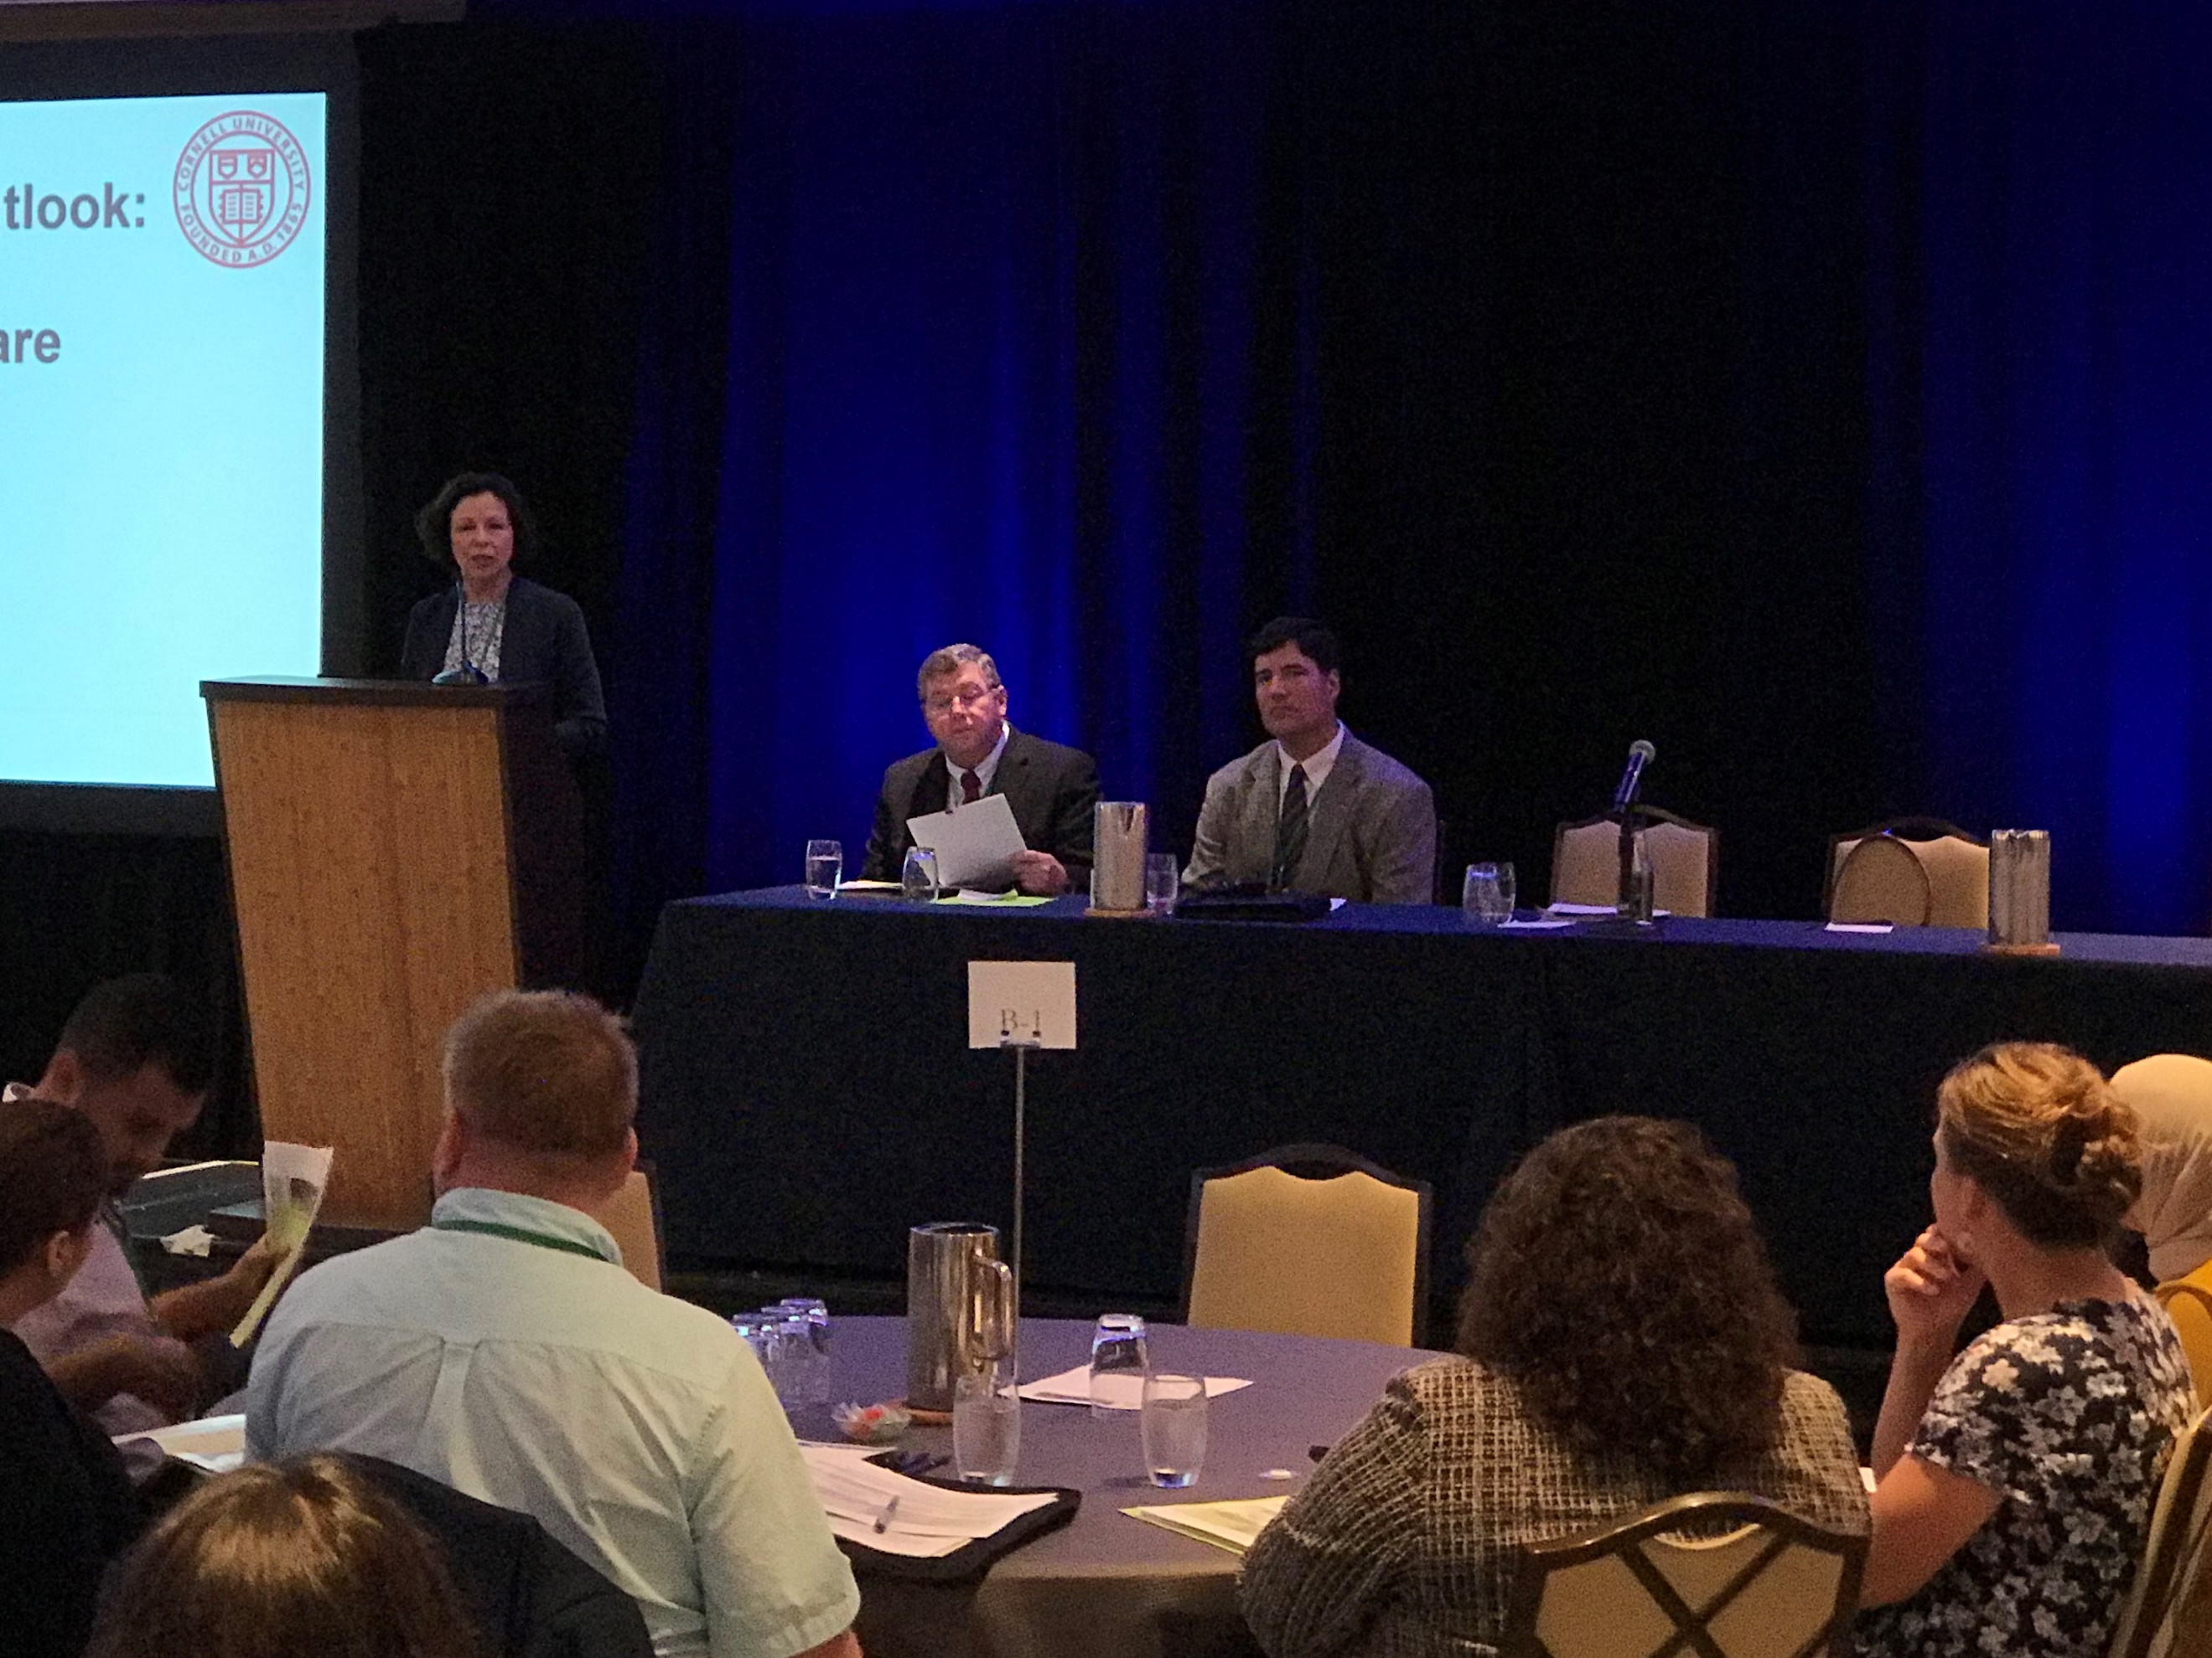
Core Presentations

During a networking lunch, the participants were treated to a special performance by the Homestead-Miami Mariachi Conservatory (HHMC) band. This band is an after-school music program with a special focus on children of farmworker background.

In the afternoon, a second Core Presentation was presented by Ms. Joanne Bogart, Office of Policy Studies, U.S. Department of Education. Her presentation was on the federal, state, and local perspectives regarding findings from the study of the implementation of the ESEA Title I, Part C – Migrant Education Program. Her study questions focused in on ID&R; The use of the MSIX system; Services to migratory children; and Collaboration with other programs. A panel of speakers were asked to share their perspective from the national, state, and local view in response to the findings and the study questions that were used. The panel consisted of Ms. Lisa Gillette, Director, Office of Migrant Education, U.S. Department of Education (Federal perspective); Ms. Carmen Medina, Director, Pennsylvania State Migrant Education Program (State perspective); and Dr. Jose Salinas, Director, Ohio Migrant Education Center (Local perspective). A work group discussion guided by focus questions followed this session.

The final Core Presentation of the day was done by Mr. Francisco Garcia, Executive Director of IMEC, and Dr. Jose Salinas, Director of the Ohio Migrant Education Center. They took the participants through a journey through Migrant Education’s past, present, and future. A short video that was produced by Dr. Salinas concluded their presentation.

Mr. Solomon Kaulukukui, Symposium Consultant, opened the second day of the symposium by sharing some highlights from the two work group discussions from the previous day. The first Core Presentation of the day was provided by Ms. Lisa Gillette (Director) and Ms. Sarah Martinez (Policy Lead) who are both from the Office of Migrant Education, U.S. Department of Education. Both presented to the participants a national perspective of the status of the migrant education program using data and updated information. This was followed by an educator’s panel which was facilitated by Mr. Tomas Mejia, MEP State Director from Colorado. On the panel was Dr. Jim Rollins, Superintendent, Springdale School District, Springdale, Arkansas; and Dr. Rosemary Hughes, Director, Bureau of School Support, Pennsylvania Department of Education. Both panelists talked about what they are doing at their level on the subjects of policies to practice equity, education, and emotional needs of migrant students at the state and local level. Ms. Ruth Ryder provided reactions/comments from the federal level regarding the information that was shared by both panelists.

IMEC members, Mr. Brad Whitman (Pennsylvania) and Ms. Sue Henry (Nebraska) provided the group with some of the key takeaways that they heard from the two days of the symposium. The symposium concluded with Mr. Solomon Kaulukukui sharing with the audience a video highlights from the two days of the symposium. This video was shot and produced by Mr. Mark Dodge (Kansas). Mr. Jonathan Fernow thanked the presenters and participants for their active participation and noted that a copy of the PowerPoint presentations delivered during the symposium Core sessions as well as the videos that were shown will be placed on the IMEC website at www.imec-migranted.org.

Organization of the Symposium Proceedings Document
The table discussions after the Thursday’s Core Presentations were recorded by the three Lead Room Facilitators, Mr. Brad Whitman (Pennsylvania); Mr. Tomas Mejia (Colorado); and Mr. Jonathan Fernow (Oregon) and their summary was included in the summary report for each question that was discussed during the work group session. The summary report is included in the next section of this report along with an analysis of the conclusions and recommendations. The source data is found in Appendix C. The final section of these Proceedings includes action items for decision makers and policymakers.

Throughout the report and appendices, quotes are found in text boxes that reflect the comments made by some of the core presenters and symposium participants; however, names are not included to ensure anonymity.

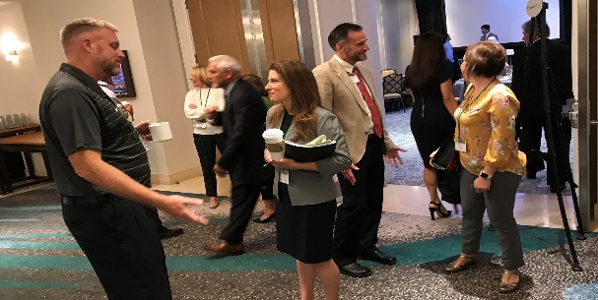
Questions for OME
Summary of Discussion From Core Presentations

Based on the Core Presentations from the first day of the symposium and the Work Group Discussion that followed, the following summaries are based on the questions that were posed to the work groups and the feedback that was gathered.
Thursday Morning Core Presentation: Agricultural Workforce Outlook: How Demographics, Technology, and Markets are Transforming Farm Labor
Presenter: Dr. Richard Stup
Question #1: What is your reaction to what was presented in your state?
- Increase in H-2A’s
- More focus on other countries (Central America) rather than (Mexico)
- Orchards are looking different/ to meet mechanization requirements
- Increased mechanization due to shortage of workers
- Politics has driven workers to not identify as migrants/ ICE raids
- Wondering what the trends will be like in the next 5 years? Could automation affect the migrant program in a negative way? Will it affect ID&R with less workers needed?
- Need to focus on emphasis on recruiting children who are presently here and not making our main focus on the decrease of the number of eligible children.
- Tariffs are really impacting farmers and the work that is available.
- Hoping that technology will make us self-reliant and we will be able to grow our own fruits and vegetables instead of importing them.
- There has been an increase in H-2A workers in a lot of states which is impacting the number of students who are eligible. States are also looking at more OSY students.
- Everyone agreed that it is very helpful to see the big picture that explains what is going on in specific states/programs considering the drop-in population. Interesting to think about how the drop-in birthrate and population may be driving the increase in automation (as opposed to the other way around). Increase in H2-A workers is changing the programs.
- We have seen our numbers decrease and feel that this trend largely aligns to the root causes presented this morning--immigration and mechanization. One question we have is around the hard data around actual agricultural jobs available (not just data on workers). We have anecdotal evidence on this, but want more specific data.
- Mechanization on the rise. H-2A workers are increasing as a result. This is affecting the program overall since H-2A workers do not bring their families. Overall decrease in numbers. Different way of looking at this issue: mechanization has not necessarily put people out of their jobs yet. This may be the trend for the future.
- Information helps understand the decrease in migrant student population. Some discussion in the group about the future of farming - mechanization is for large farms for year-round production - what does it mean for seasonal crops? Will a strawberry farmer invest in 2 million robot for 3 months a year? And are we talking about multiple robots to do multiple jobs? Planting, weeding, pruning, etc.

Question #2: What is it that you are doing in your state to address this?
- Increased ID&R efforts
- Establishing Agri-Business protocol
- Building relationships
- Focus more on OSY rather than K-12 population
- Social media to make longer/stronger connections to families
- Trauma informed approach/ care built into services
- More focus on H-2A and OSY. Increase in population of both of these two groups.
- Working closely with our state’s Department of Labor, Department of Health, and Department of Agriculture to provide services to families.
- Building relationships and trust with the community to ensure that we are identifying and serving the needs of the families despite the current political climate.
- Programs are changing to increase emphasis on older students/OSY. Some MEPs are investing in more/better technology-based classes and experiences to offer more opportunities to the younger students.
- We are working constantly to adapt to the needs of our students and families and the realities of our barriers in serving them (restrictive eligibility requirements, decreased funding, increased responsibility and service areas). We are exploring technological tools to increase communication and distance-based learning services. We are also emphasizing ID&R as a top priority to ensure we do identify every family we possibly can!
- Partnerships with communities, schools, employers, local and state agencies. Understanding cultural differences is paramount.
- Recruitment practices changing to meet the needs of OSY - recruitment during evenings and weekends, flexible work hours. Instructionally - making sure migrant children receive the same opportunities to robotics, technology and STEM classes than their non-migrant peers receive.

Question #3: How is the educational delivery, due to changes in agriculture/food/dairy/fishing, affecting migrant education services? How is it impacting your ID&R?
- More technology in lessons
- Hard to believe that in this day and age we are talking about mechanization, but yet we have places with no cell service or internet
- Mental Health services
- More focus on OSY and including H-2A workers in the state’s delivery plan. A need to hire more state recruiters to help with the ID&R.
- Focusing resources on preschool and summer services besides support for the regular school year program.
- Utilizing technology and virtual learning to support migrant children who have difficulty attending service centers due to the distance they have to travel.
- Mental health and trauma are becoming issues that families are facing due to the immigration threat. Programs need to go back to building trust with the families.
- With ESSA, schools and LEAs need to look at subgroup performances to ensure that all children are performing and being accounted for.
- There is more emphasis on OSY and life skills lessons; increased availability of STEM-based opportunities is important; programs need to be careful about over-emphasizing the goal of a college degree - illuminate the possibilities of trades, skilled labor, technology jobs that do not require 4-year degrees, etc.
- We are seeing shifting academic needs in our migratory student populations; we need to move toward viewing our students as individuals and identifying their unique, individualized educational needs, as we have some student populations who are excelling academically and some who need intensive instructional support. A particular challenge is serving newcomer students who lack formal educational experience and need adaptive, flexible school settings to meet their needs holistically.
- Change needs to happen at the federal level. More support for the program and the families are necessary. Focus on professional development and support. Parent education and advocacy is critical as well. Leadership is required to support this happening at all levels.
- Provision of services is affected because the needs are different and the availability of students is different. Programs are struggling to address educational services and are unable to address the kid’s social and emotional needs. States that are recruiting kids effectively are allowing for flex time of recruiters, ID&R on evenings and weekends, and other similar ideas.
Question #4: How has the current immigration issues, migrant issues, as well as the issue of climate change affected the agricultural business in your state?
- Current usage of word Migrant hurting program
- Weather and Tariffs have hurt
- Not saving money due to maintenance
- Different usages for land (hemp/Marijuana)
- Changing populations of migrant families in some states than what was seen in the past.
- The term “migrant” and “immigrant” is creating identity issues for many migrant students and their families. Most do not want to be associated with these groups in fear of opening their doors to anyone or having ICE raids. Programs need to look at ways of using other variations of the name of the program in order to get the trust of families to participate in the services.
- Climate change is affecting states in a very negative way. Change in weather patterns have affected crops. The trade “war” with the implementation of tariffs has had an impact on farms this past summer.
- Immigration fears are common across the programs and getting families to trust recruiters and service providers continues to be a challenge; climate change has been particularly noticeable this year in all of our state represented - flooding, record heat, record snowfall already… this has all affected the ability for migrant workers to find and keep work.
- Families and growers are reluctant to identify with a “migrant” label and are fearful of immigration under new policies. We must establish relationships and build trust across programs and through existing family and grower connections.
- Most H-2A visas are not qualified for the program services because most of them came to work without bringing their families.
- Climate change has addressed all crops and agribusiness. Cannot control this. Families that can legally come to the US but are choosing not to due to political climate. don’t want to be identified as part of the migrant program. Have had to change how we introduce the program. Families are refusing services.
- Fear and misunderstands about immigration, ICE, public charge is making it difficult for recruiters to develop trust with the families. “ICE is in town” is code in our community for families not showing up at events.

Thursday Afternoon Core Presentation: Federal, State and Local Perspectives Regarding Findings from the Study of the Implementation of the ESEA Title I, (Part C) – Migrant Education Program
Presenter: Joanne Bogart
Panel Response to the Findings: Lisa Gillette (OME); Carmen Medina (PA); Jose Salinas (OH)
Question #1: What is your reaction to what was presented and its impact to your state? What has been successful? What has been barriers?
- Educate all districts of MSIX
- Have MEP staff serve multiple roles ex. Recruiter/Student Support/Parent Support
- Provide lessons for OSY at time of recruitment
- Barrier- no cell service or internet in some areas
- Much of the report confirmed what we are seeing with much of what we do. Need to be more innovative and reach out to our migratory students.
- Providing data for MSIX is difficult and sometimes out of our control. Obtaining statewide testing scores and credit accrual is time consuming and finding personnel to help is difficult and can be costly. Implementation of MSIX at the local level can be challenging and varies by states.
- MSIX continues to be a tool that increases in usefulness, more training and access to answers would be beneficial.
- Benefits to using MSIX/ but would like more training on how to optimize MSIX.
- Encourage more timely usage particularly with counselors and those outside the MEP (need follow up and training)
Question #2: What assumptions made in ESSA or the MEP program should researchers, advocacy organizations, or think tanks be exploring?
- Amount of money spent on MSIX versus services/utility
- Other possible usages of Migrant funds beyond what is currently done?
- How are ID&R positions evolving to meet the changing migrant demographics?
- Should the pool of qualifying work be expanded beyond agricultural only? Other highly mobile professions face many of the same hurdles due to their lifestyle.
- 3 years of may not be enough for eligibility and service provision.
- The ability to go beyond graduation and support college preparation/trade school i.e. Example high school tech schools that get college credit.
- There isn't a lot of research on migrant students and what educators can do to meet their unique needs.
- How do we advocate and provide more services to meet the needs of these students when ESSA puts more emphasis on student achievement?
- The use of the term “migrant” should be evaluated by researchers. Social isolation should also be examined as these students need to have a sense of belonging to something. Migrant children who have experienced trauma need to have their needs addressed with migrant services.
- How do we increase eligibility? How can we facilitate collaboration and communication between agencies who may feel they are competing for migrant enrollment?
- Need to incorporate ag trends in any ESSA changes/ Expand definitions/ understand the diversity of the students we serve.
- Every time we try to find ways to recruit more children, we make it more complicated.
Question #3: What are long-term research questions that should be answered before the next ESEA reauthorization?
- Mental health and its effects in the migrant population
- Find out the outcomes of students who have settled out to see if we should extend the eligibility from 3 years to 5 years.
- 6 years of student eligibility vs 3 years
- Expand qualifying work to include other migrant populations
- Wonder if farmworkers who move and the ones who settle out can have some of the same issues. Are their needs the same or different? Need to extend the 36-month eligibility as well as expanding qualifying activities.
- The GPRA’s for Title I, Part C is linked to student achievement. If the program is supplemental, do we have a specific way to show that what we provide for interventions has a direct impact on the student’s ability?
- Are there other ways to evaluate the effectiveness of the MEP program other than using state content assessments? How do we get more parents involved in the program and successful practices of the Parent Advisory Council (PAC)?
- Would like to see research on how increasing eligibility would impact results for students in the same demographic. Also see the need to increase research on the effect of ACEs and trauma in the migrant student population.
- What are the effective models for migrant education programs (i.e. regions, combination, consortium)?
- Impact of trauma on migrant students
- Impact of SEL curriculum on students and is this always equitable? Intersections of identity (including race, ethnicity, sexual orientation, etc.) on students and how this is perceived by teachers. What does high quality professional development look like? This is an adult problem not a kid problem. Cultural humility
- What are the elements of an effective short-term after-school program? It is hard for 3-4 weeks long programs to evaluate effectiveness.
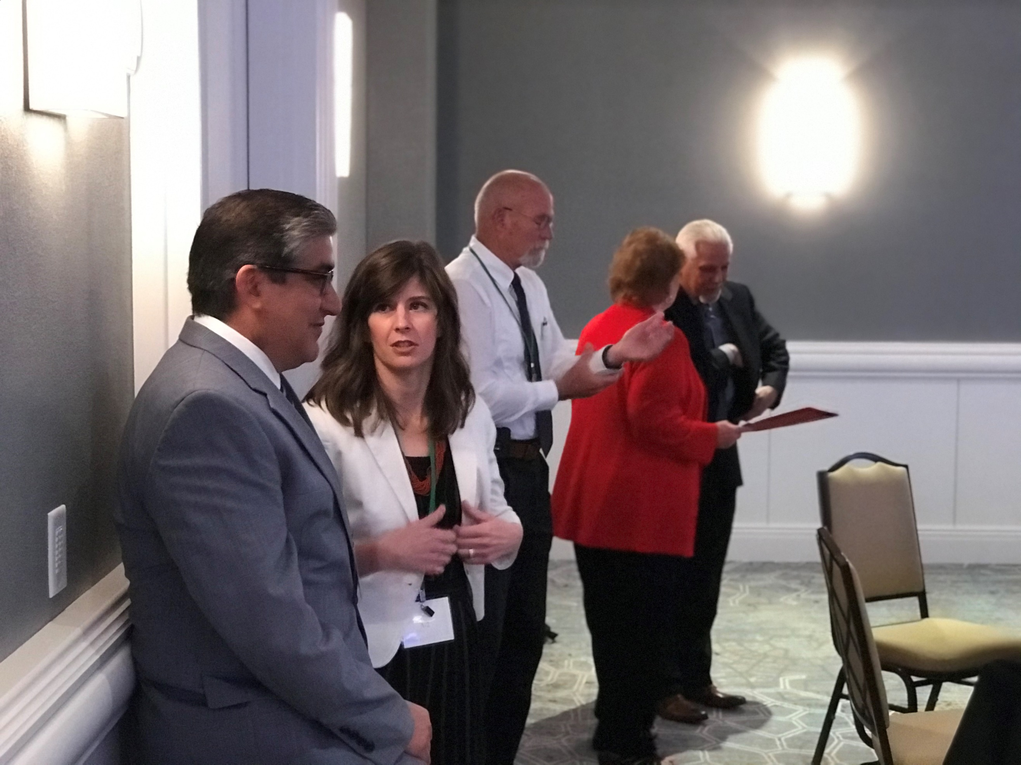
Networking with OME

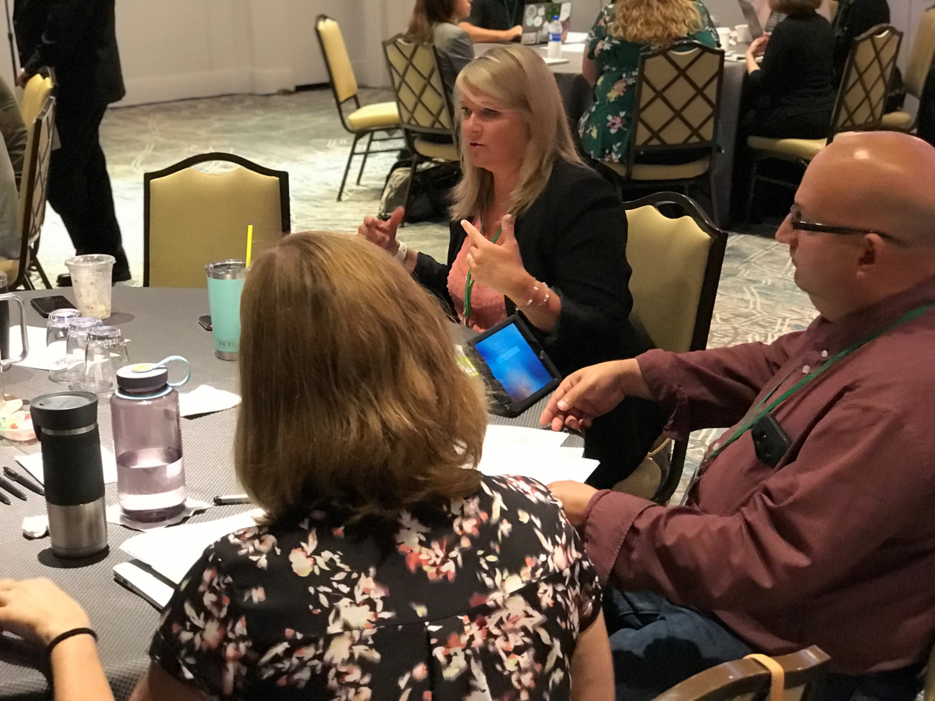
Sharing of Ideas

“Work on diversity to get those to the tables while working with the communities.” “Nothing about us, without us”.
Conclusions and Recommendations
The following conclusions and recommendations are made based on the five Core Presentations and the two work group sessions that made up the agenda for this year’s IMEC’s National Symposium: “Moving Forward by Working Together”. The recommendations are clustered into three categories which are offered for consideration and implementation by local schools and school districts, SEA’s, OME, and other MEP decision makers and policymakers.
- Shortage of Labor Workers vs. Mechanization
  - Conclusion:
    - Several occurrences have caused a decrease in the work population. Unemployment rates are low with more Americans working as well as over the past decade, unauthorized immigration caused for a decrease in the work population. However, this is not the only reasons for a shortage of workers according to Dr. Stup’s presentation. Fewer young Mexicans are looking for work which is tied to the nation’s decline in the fertility rate. More are staying in Mexico, including women, to work. Guatemala’s data is still growing but not as pronounced as Mexico.
    - Due to a shortage in labor workers, farms still need to have their crops picked. Farms are looking at alternative ways to grow their crops which makes it easier to pick with machines. This is a high capital investment to replant trees to create crops to be picked by robots but the labor shortages will escalate the investment in technology. Thus, heavy manual and repetitive labor will be largely replaced by automation.
    - Climate change is affecting states in a very negative way. The change in the weather patterns is affecting the ability for migrant workers to find and keep work. Recent tariffs and trade wars have affected farms too as well this summer.

  - Recommendations:
    - Mexico may no longer be the main country where agriculture workers are coming from. Farms may have to look at growth areas such as Africa, Asia, and Central and South America as a population to be tapped.
    - Take a look at the 2017 Agricultural Census to see a significant reduction in workforce for agriculture and the farms that are affected not only nationally, but at the state and local level.
    - Employers need to recruit from all walks of life (rural-urban, native-immigrant) to find careers that combine biology, technology, and information. Could also be a part of the school’s STEAM program. Ensure that migrant children receive the same opportunities in these STEAM programs as their non-migrant peers receive.
    - Although climate change is out of our control, policy makers should look at ways to support farms (especially small ones) who are affected by not only the change in the climate but by the tariffs and trade wars that prevents them from raising and selling their products.

- The MEP Program Moving Forward
  - Conclusion:
    - Although all states are using MSIX and submitting data into this system, the MSIX system is not being used to its fullest capacity. States are struggling to find personnel and time to maintain their data collection to feed into MSIX.
    - States would like to see the student’s eligibility for services by the MEP program moved from 3 years to 6 years. As a supplemental program, it is hard to measure student achievement if students are settling out early than later. Resources and interventions to meet the needs of the students and their families takes time to make a difference. Mobility of families will always be an issue if families do not settle out.
    - Creative ways need to be looked at in utilizing the migrant funds and the resources in order to meet the needs of the migrant families. Collaboration with other agencies that also provided support were some of the suggestions. Equitable services and issues like mental and emotional health are new challenges that the migrant programs are facing.
“Priority for services (PFS) is intended to help states direct services to migratory students most in need.”
    - How ID&R was done in the past has now changed due to the changes in the agricultural field. Farms are having to use more H-2A and OSY workers to make up for the shortage in the work force. State and local levels are having to relook at how they are doing ID&R so that they can be more effective and how they can do it differently. More time and money are being spent to focus in on the ID&R efforts by hiring more staff to find the families. The MEP program is a supplemental program whose resources may be limited in meeting the needs of the migrant children and their families.

  - Recommendations:
    - More training is needed on how to optimize the use of MSIX at both the local and state level. Maybe training should be done based on the size of states as smaller states needs will be different from that of a larger or middle size state.
    - Continue the discussion with policy makers and OME on increasing the eligibility status in the program from 3 years to 6 years.
    - Professional development should continue to be built in at both the national, state, and local levels to share with practitioners on how to address the unique needs of the migrant students and their families. Networking time at all levels between states as well as between districts on how to best maximize the use of migrant funds with programs of similar needs and structure.
“The unit of change is the school, district, state, not the student.”
    - Find ways to leverage your agricultural data that will help to support your ID&R efforts.
    - Look at the impact that the H-2A program is having at the state and local level. Focus on OSY workers who may be eligible for the migrant education program in addition to the K-12 students.
    - Collaborate with other national, state, and local agencies who also work with the migrant population that your program serves to provide additional resources to the families.

- What Have We Learned from ESSA So Far?
  - Conclusion:
“Teach them ALL; ALL means ALL.”
    - The GPRA indicators are linked to student achievement, yet the migrant program is supplemental in nature. Are there other ways to evaluate the effectiveness of the MEP program other than using state content assessments? Parent involvement has always been a part of the MEP program. How can programs get more parents involved in their child’s education?
    - Migrant students and their families truly have some unique needs. However, there is little research on what educators can do to meet these needs. Besides academic needs, issues such as equitable services and mental and emotional health are now surfacing as needs for the migrant families.
    - The terms “migrant”, “immigrant”, and “migratory” is causing confusion among practitioners who are not part of a migrant education program. Eligible families do not want to be associated with either one of the groups for fear of any possible retribution that has occurred to others in the past. ICE raids are also having an effect on families. The trust issue becomes a major hurdle to overcome for the migrant program as they try and work with the families they are trying to serve.

  - Recommendations:
    - A think tank group should be formed to talk about the issues mentioned in this report and how the Title I, Part C program can continue to move forward under ESSA and the changing times that are happening across our nation. The group would be composed of a cross section of participants similar to the makeup of the IMEC organization. Also included in the discussion is members from OME and policy makers at the national level. Recommendations would come from this group to be shared with OME and with policy makers as ESSA goes into its next reauthorization period.
    - Allow states more flexibility in the use of their migrant funds to address the unique needs of the migrant population.
    - Encourage collaboration at all levels and among all federal programs who provide services to the migrant population. Pool resources to meet the unique needs of these families.
    - Continue to educate those outside of the migrant education program on how the program defines a “migrant” worker and/or family.
    - Build trust with the families and how the program can benefit them and not have a negative label placed on them by their participation in the program.
    - As much as possible, use the word “migratory” in talking about the families that are served by this program.

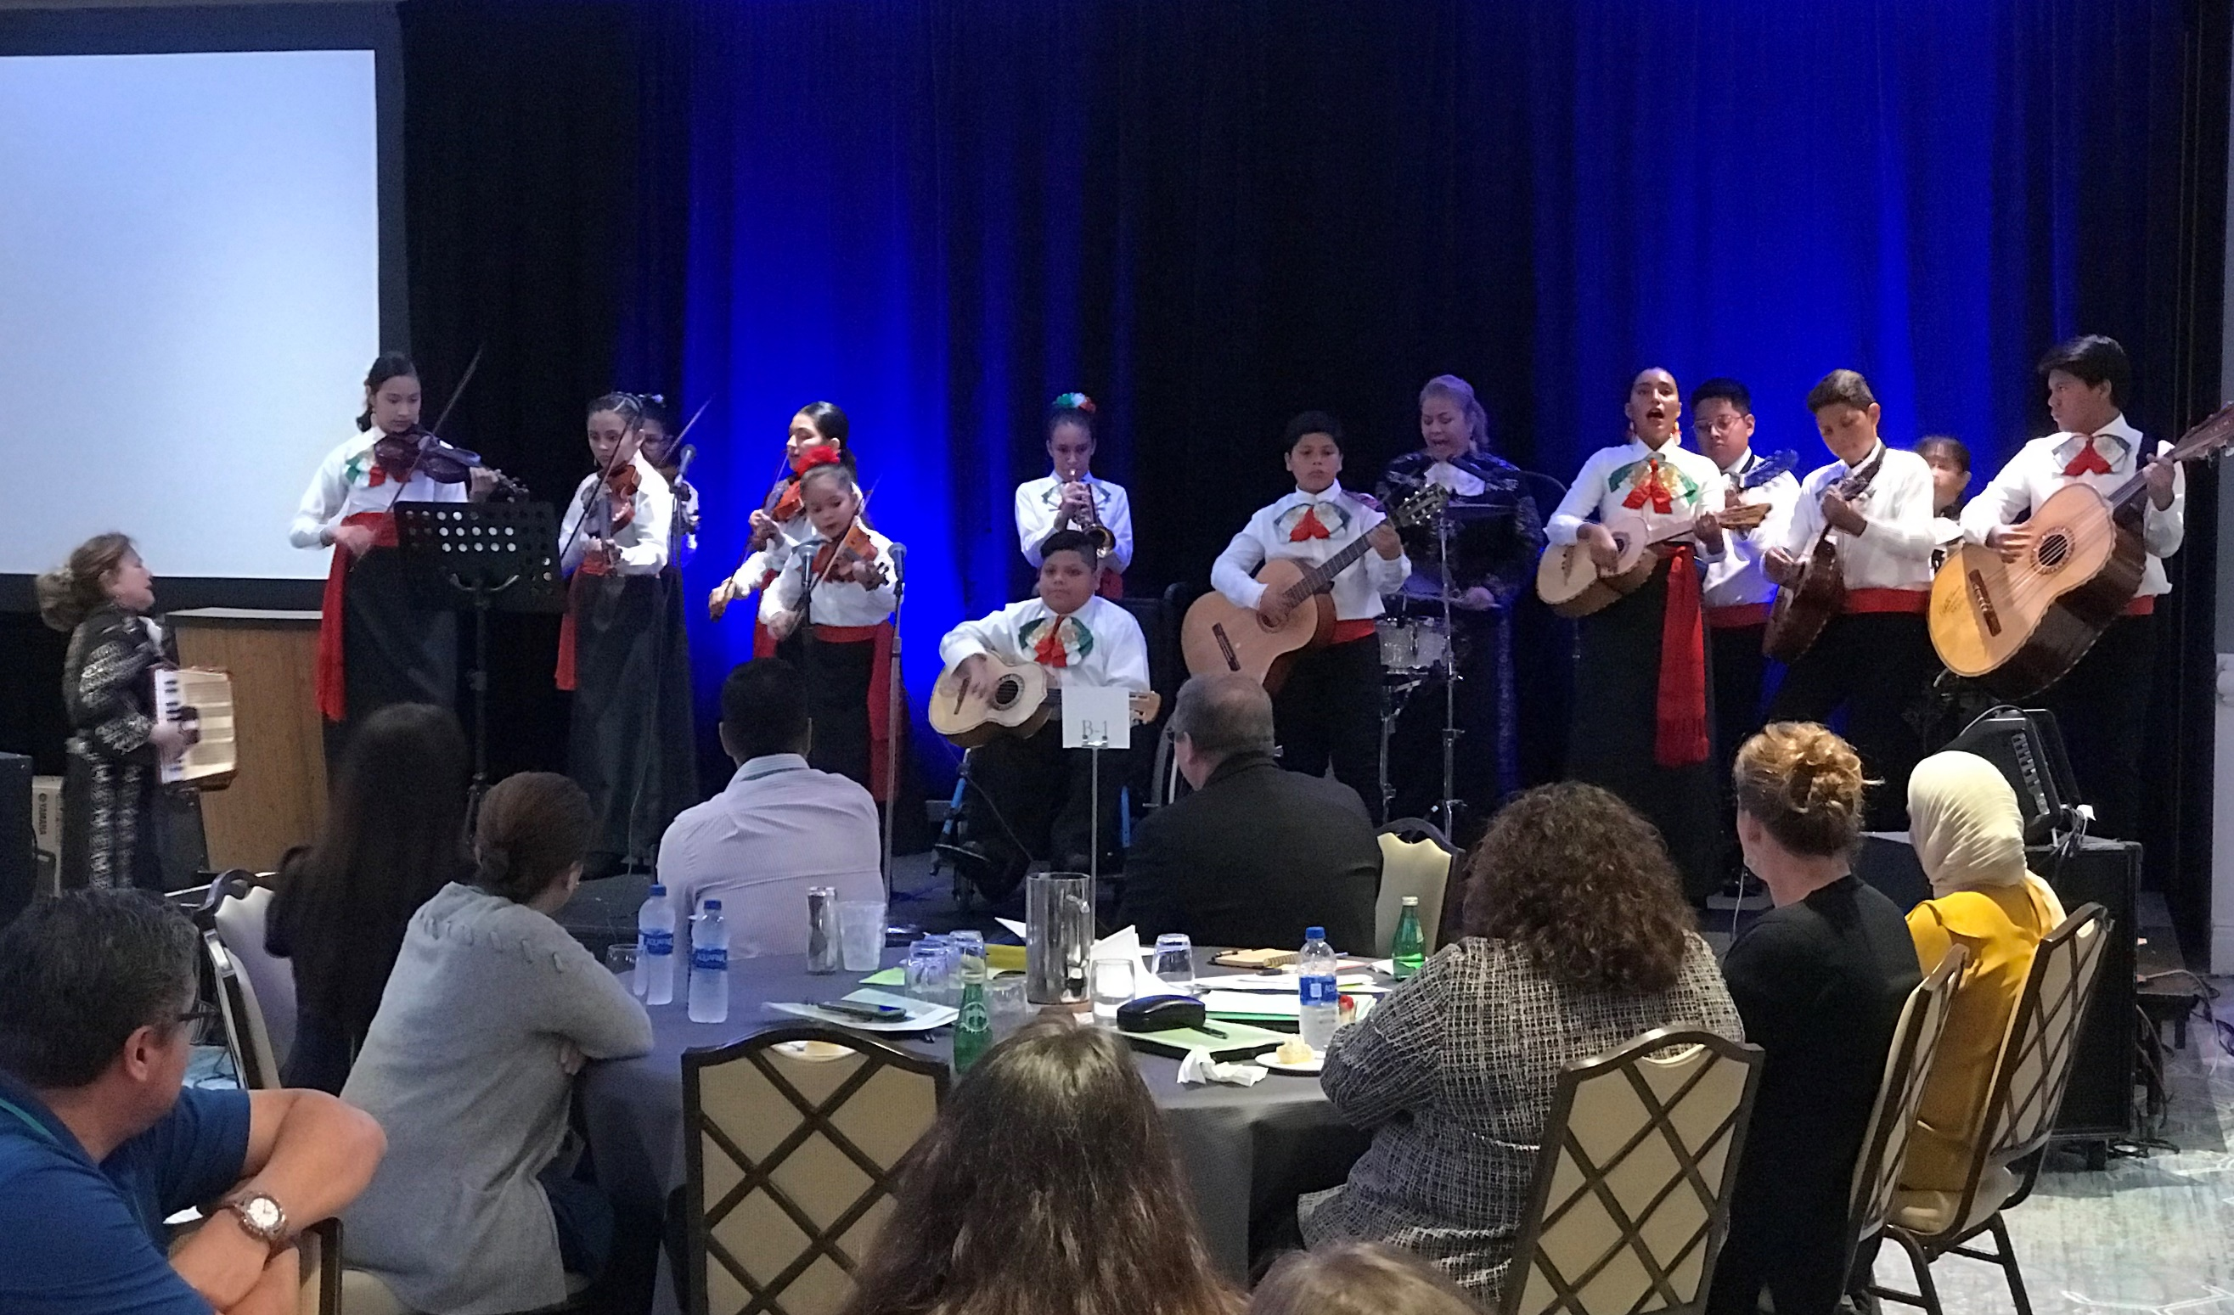
Luncheon Performance

“You can’t have excellence without equity.”

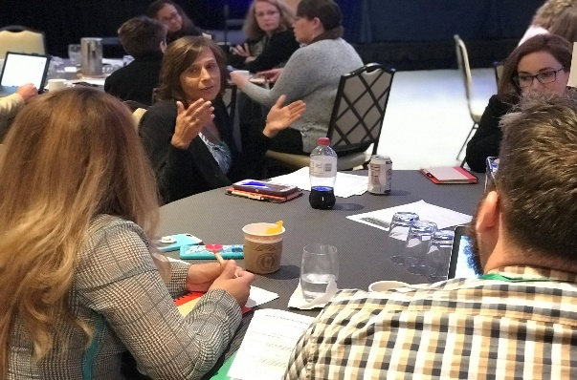
Best Practices

Follow-up to the Symposium
Based on the evaluations that were submitted by the participants, the 3rd IMEC National Symposium “Moving Forward by Working Together” was a success. 38% of the responses said that their desired outcome for the symposium prior to their attendance was to learn new things that can help them with their job and their migrant program. Another 38% of the responses was looking forward to the time to network/collaborate with their peers and colleagues. Did the symposium accomplish this? 95% of the responses said “yes” that the symposium meets their desired outcome. 64% when asked to give “other thoughts” said that they were appreciative of the symposium and the work of the committee members.
So, the question becomes, “Where do we go from here?”. This Proceedings report is based on the core presentations, the work group discussions, and the evaluation feedbacks. The IMEC membership will need to look at recommendations that came out of this symposium and see how it fits to IMEC’s Strategic Plan which has four primary focus areas: Relevance; Sustainability; Advocacy; and Organizational Effectiveness. Through their strategic plan, IMEC can continue to play a leadership role in advocating and gathering information to aid policy makers as requested.
This Proceedings report will be presented to the IMEC’s general membership during their January, 2020 meeting to encourage discussion and determine further action based on the outcomes reported from the symposium. The suggestions gathered will be used as appropriate to finalize this report and for future symposium planning. IMEC will post the Proceedings on its website and share this document with OME as it continues to develop non-regulatory guidance to support ESSA.
As in previous symposiums and as a follow up to this symposium, a committee or work group of IMEC members or their designees should be convened to consider policy implications for SEAs, LEAs and avenues to work with OME to jointly address action items. The group should come up with shared timelines, who should be responsible for what, and deliverables should be developed from these meetings. Outcomes from this can be used also to revise and support future updates to IMEC’s Strategic Plan.
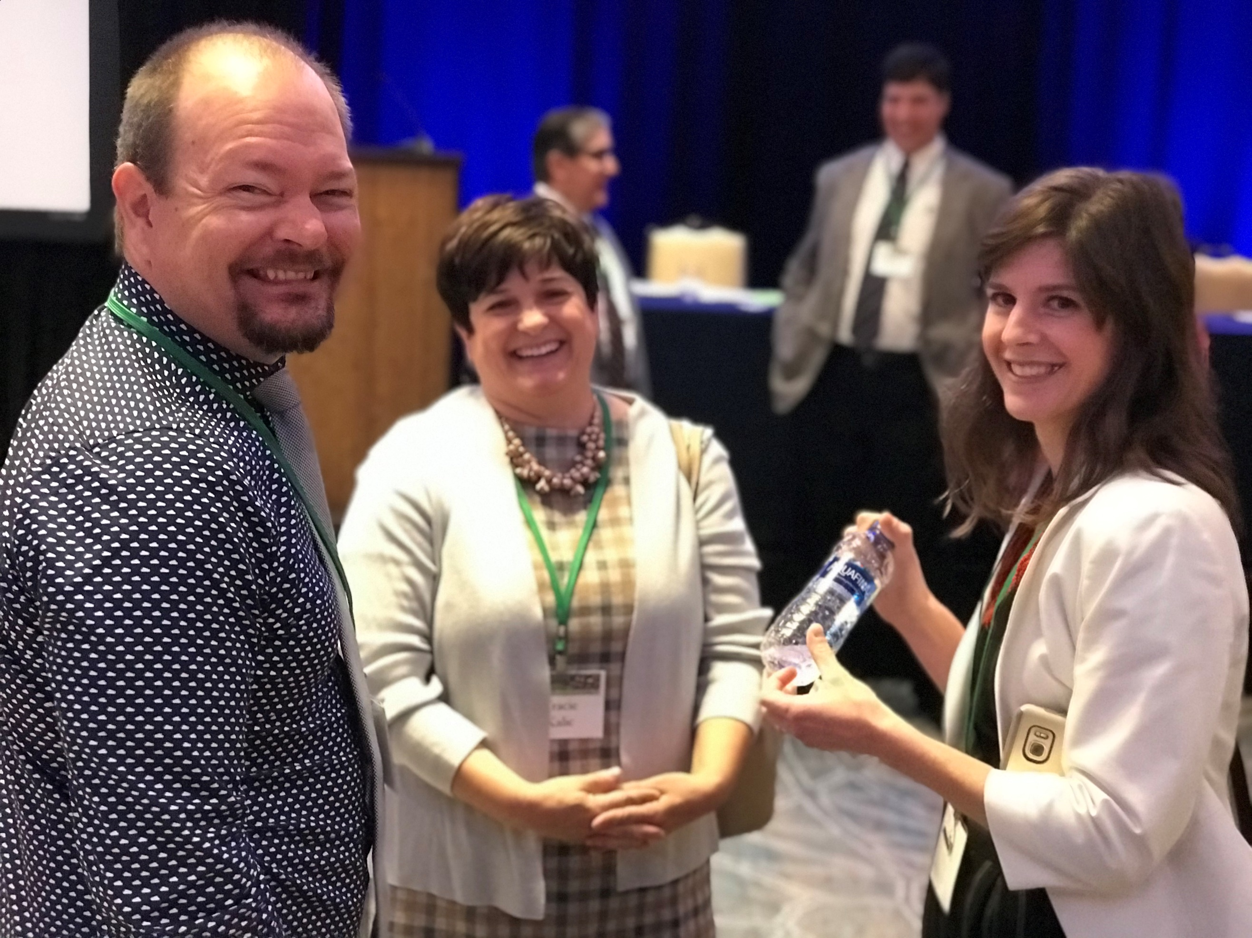
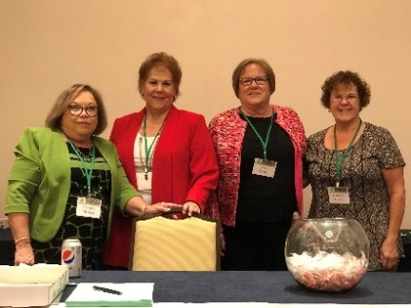
Good Times, Fun, and Laughter
Symposium Participants

Appendices

Appendix A – Symposium Contact Info
Appendix B – Symposium Agenda
Appendix C – Symposium Summary from the Work Groups
Appendix D – Summary of Evaluations
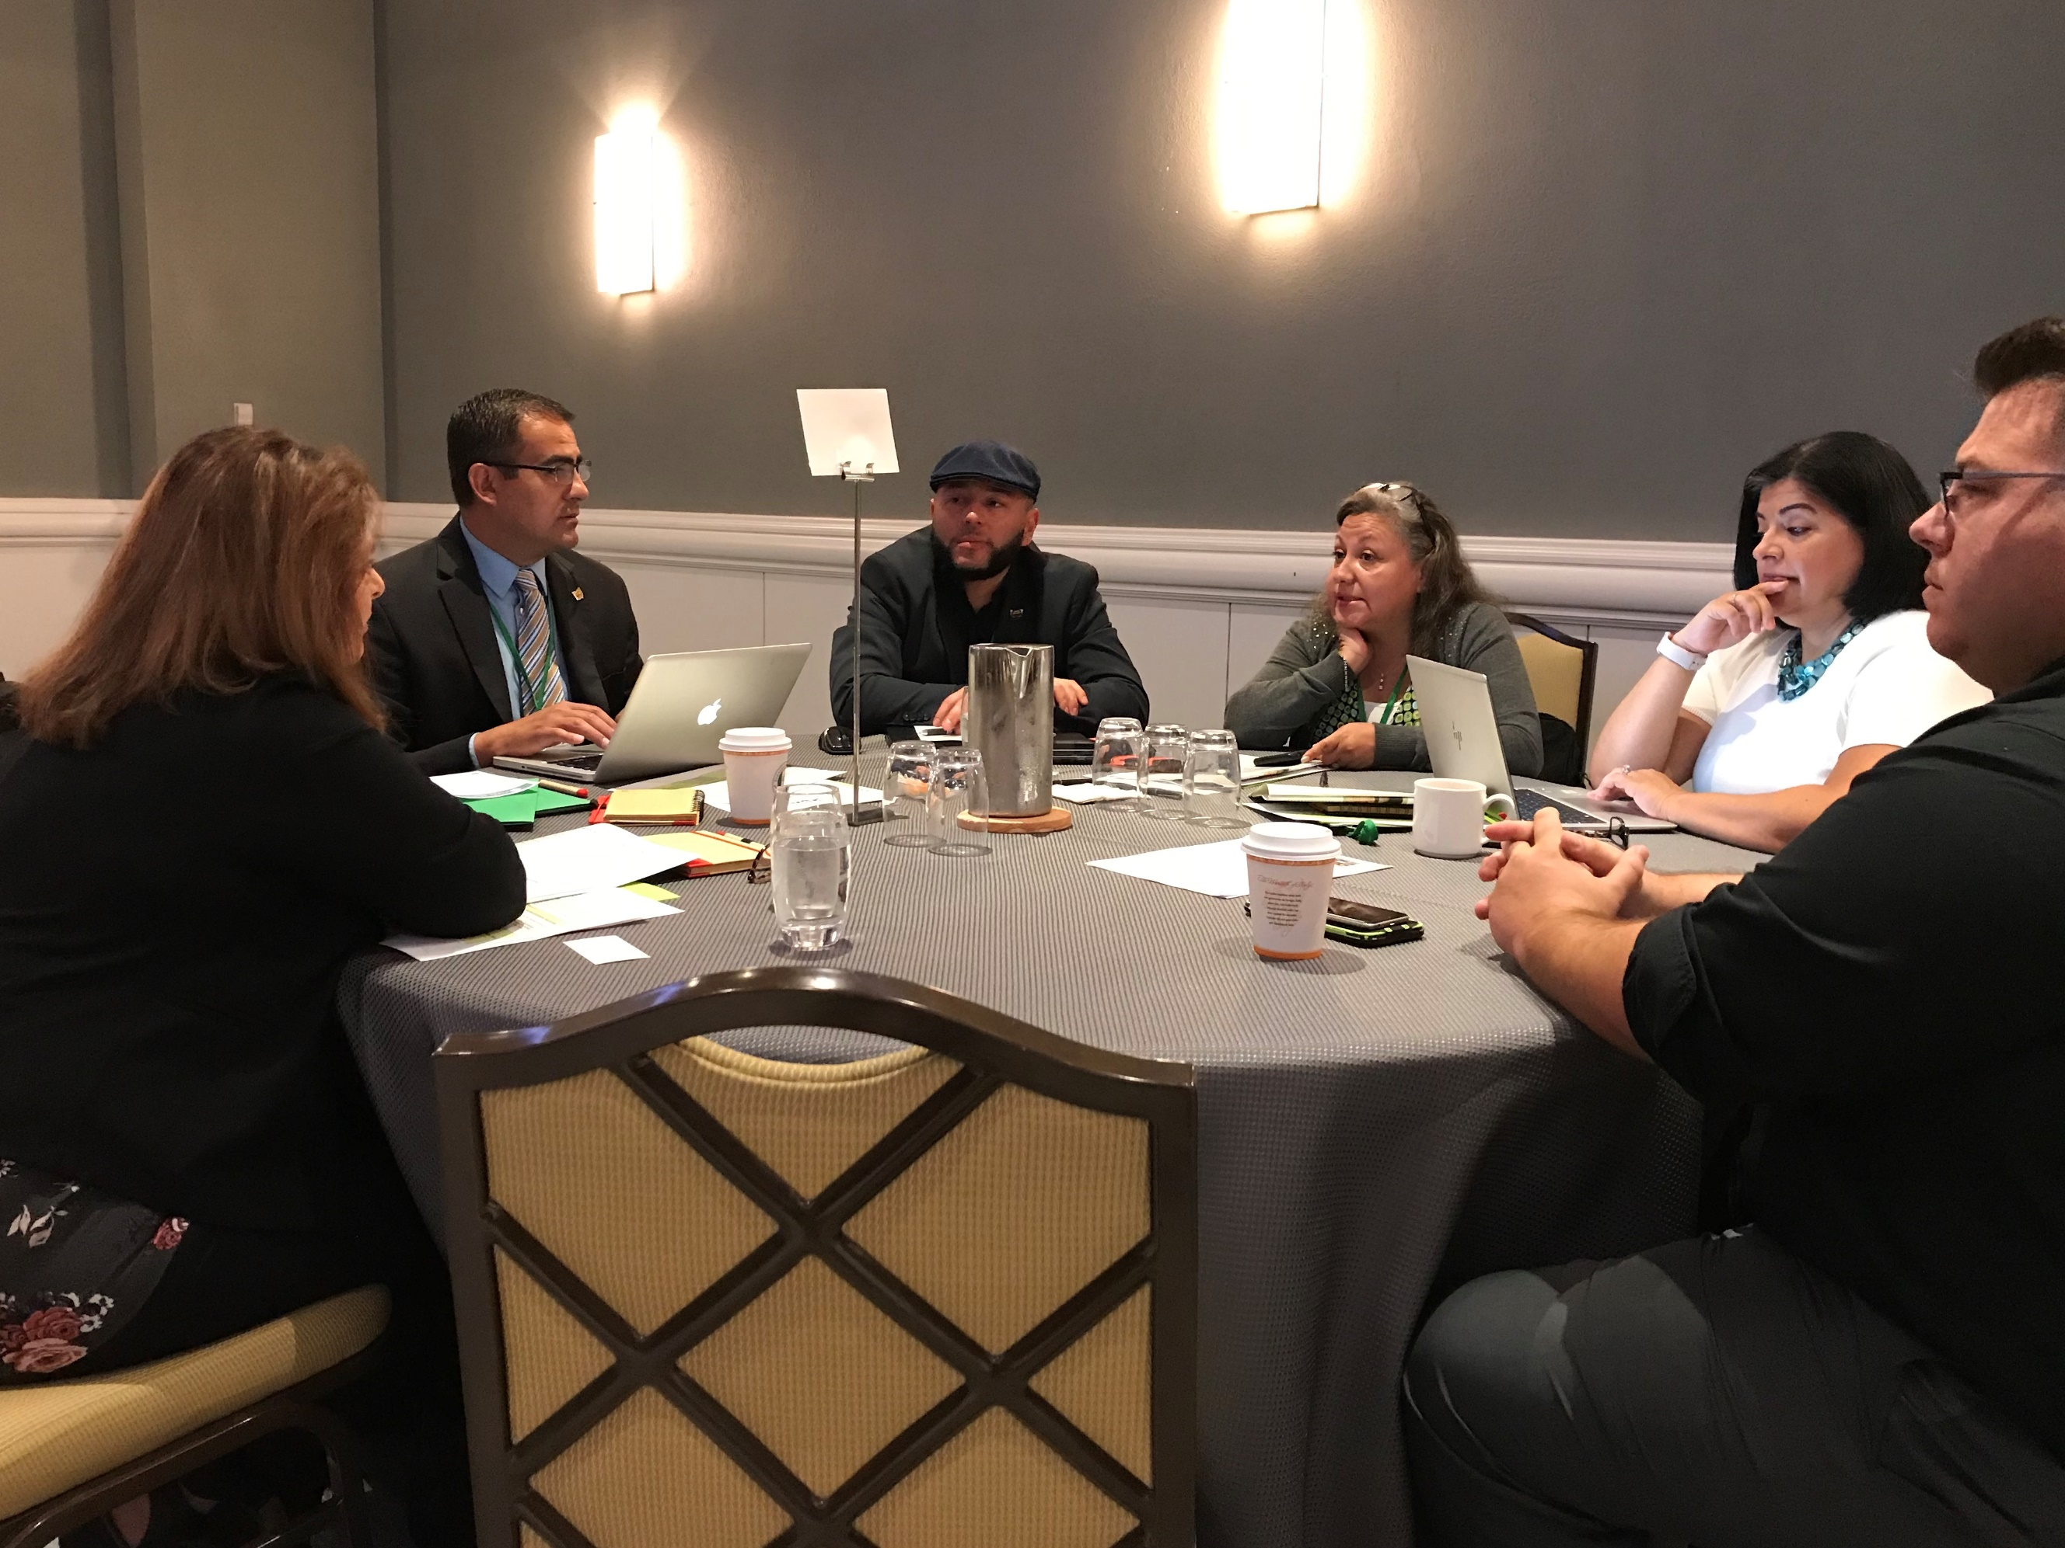
Gathering Knowledge from Other States

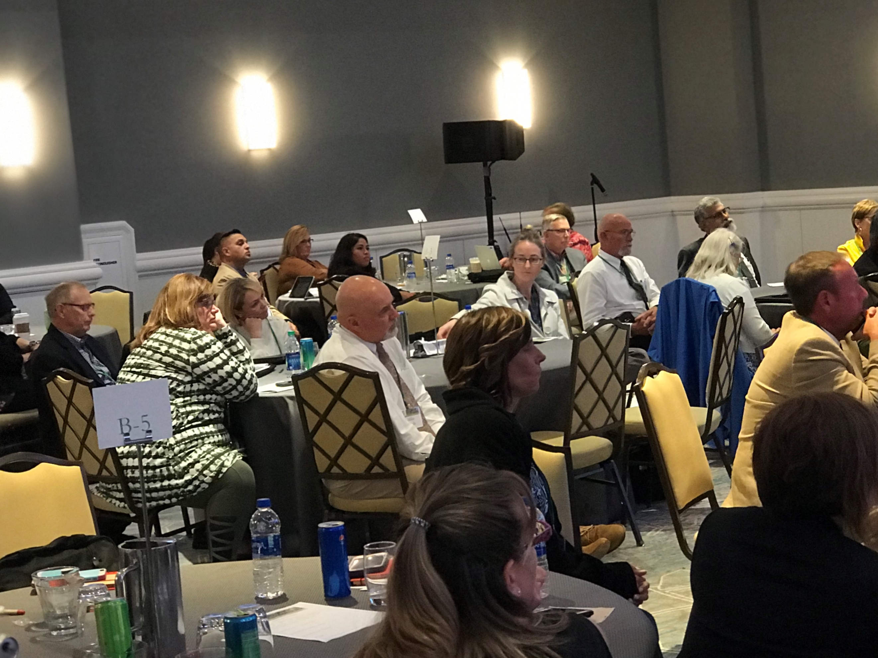
General Session

“Professional Development is not something you do to teachers; it is something you do with teachers.”
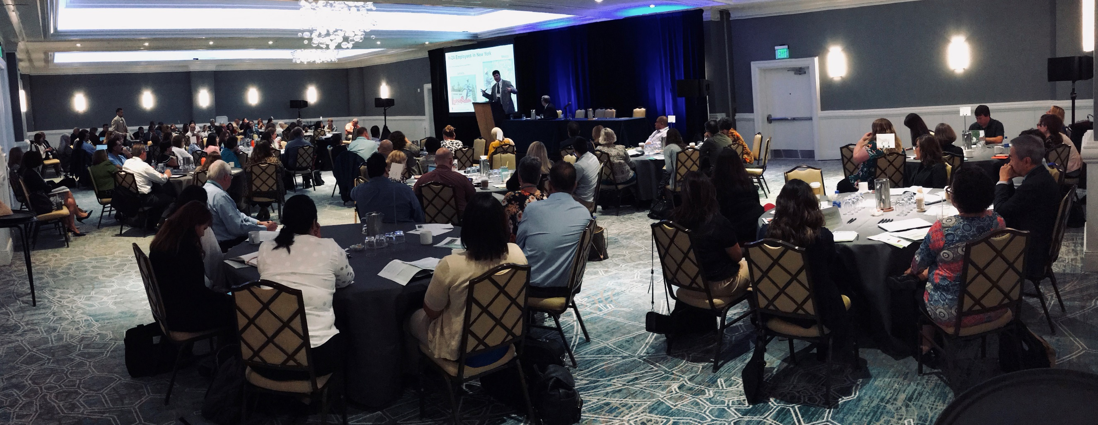
Interstate Collaboration

Appendix A – Symposium Contact Info

For information or follow-up with the Symposium attendees, please contact the Interstate Migrant Education Council at 1 Massachusetts Ave, Suite 700, Washington DC 20001 or email: Nancy.wiehe@ccsso.org. Below is a list of websites mentioned in this Proceedings document and the link to the presenter’s website.
- Interstate Migrant Education Council – Francisco Garcia, Nancy Wiehe
http://imec-migranted.org/
- U.S. Department of Education, Office of Elementary and Secondary Education, Office of Formula Grants – Ruth Ryder
https://www2.ed.gov/about/offices/list/oese/index.html
- U.S. Department of Education, Office of Migrant Education – Lisa Gillette, Sarah Martinez
https://www2.ed.gov/about/offices/list/oese/ome/index.html
- U.S. Department of Education, Office of Planning, Evaluation and Policy Development – Joanne Bogart
https://www2.ed.gov/about/offices/list/opepd/index.html
- Cornell University Agriculture Workforce Development - Dr. Richard Stup
https://agworkforce.cals.cornell.edu/contact/
- Arkansas Springdale School District – Dr. Jim Rollins
https://district.sdale.org/o/springdale-public-schools/page/superintendent--141
- Pennsylvania Department of Education – Dr. Rosemary Hughes
https://www.education.pa.gov/Pages/default.aspx

Appendix B – Symposium Agenda

DAY 1: Thursday, 10/17/19
8:30a-9:00a |  | Welcome, meeting overview, and brief summary of the first and second National Symposiums  Opening Remarks |  |  | Aqualea Grand Ballroom A, B, C  Jonathan Fernow, Chair IMEC /Oregon MEP Director  Ruth Ryder, Deputy Assistant Secretary, Office of Formula Grants, Office of Elementary and Secondary Education, US Department of Education
9:00a-10:15a |  | Core Presentation: Agricultural Workforce Outlook: How Demographics, Technology, and Markets are Transforming Farm Labor |  |  | Aqualea Grand Ballroom A, B, C  Richard Stup, Ph.D. College of Agriculture and Life Sciences, Cornell University
10:15a-10:45a |  | Break and transition to small group meeting rooms
10:45a-12:00p |  | Workgroups: Participants are assigned to Tables (1-5) in Session A, B, or C as noted on the front of your folio. Discussion will focus on the implications of the Core Presentation. The speaker will rotate between Workgroups to listen to discussion.
 |  | Aqualea Grand Ballroom A  Workgroup A – Facilitator:  Brad Whitman |  |  | Aqualea Grand Ballroom B  Workgroup B – Facilitator:  Tomas Mejia | Aqualea Grand Ballroom C  Workgroup C – Facilitator:  Johnathan Fernow
12:00p-1:30p |  | Networking Luncheon Performance by the Homestead-Miami Mariachi Conservatory |  |  | Aqualea Grand Ballroom A, B, C
1:45p-3:00p |  | Core Presentation: Federal, State and Local Perspectives Regarding Findings from the Study of the Implementation of the ESEA Title I, Part C Migrant Education Program |  |  | Aqualea Grand Ballroom A, B, C  Joanne Bogart, Office of Policy Studies, US Department of Education  Panel Response to the Findings:  Lisa Gillette, Director, Office of Migrant Education, US Department of Education (OME) Federal Perspective  Carmen Medina, Director, Pennsylvania State Migrant Education Program  State Perspective  Jose Salinas, Director, Ohio Migrant Education Center  Local Perspective  Jonathan Fernow (OR), Chair IMEC Facilitator
3:00p-3:15p |  | Break and transition to small group meeting rooms
3:15p-4:15p |  | Workgroups: Participants are assigned to Tables (1-5) in Session A, B, or C as noted on the front of your folio. Discussion will focus on the implications of the Core Presentation. The speaker(s) will rotate between workgroups to listen to discussions.
 |  | Aqualea Grand Ballroom A  Workgroup A – Facilitator:  Brad Whitman |  |  | Aqualea Grand Ballroom B  Workgroup B – Facilitator:  Tomas Mejia | Aqualea Grand Ballroom C  Workgroup C – Facilitator:  Jonathan Fernow
4:15p-4:30p |  | Break and transition to Ballroom
4:30 p-5:00p |  | Core Presentation:  A Journey Through Migrant Education’s Past, Present and Future |  |  | Francisco Garcia, Executive Director, Interstate Migrant Education Council  Jose Salinas, IMEC Member (OH)
 | DAY 2: Friday, 10/18/19
 | 8:00a-8:20a |  | Welcome and Summary of Day 1 Outcomes | Aqualea Grand Ballroom A, B, C  Jonathan Fernow, Chair IMEC  Solomon Kaulukukui, Symposium Consultant
 | 8:20a-9:30a |  | Core Presentation:  Status of the Migrant Education Program: A National Perspective | Aqualea Grand Ballroom A, B, C  Lisa Gillette, Director, Office of Migrant Education, US Department of Education (OME)  Sarah Martinez, Policy Lead, Office of Migrant Education, US Department of Education (OME)
 | 9:30a-9:45a |  | Break
 | 9:45a-11:45a |  | Core Presentation:  Policy to Practice Equity, Education and Emotional Needs of Migrant Students at the State and Local Level  Reactions/Comments from the Federal Level | Aqualea Grand Ballroom A, B, C  Jim Rollins, Superintendent, Springdale, SD, Springdale, Arkansas  Rosemary Hughes, Director, Bureau of School Support, Pennsylvania  Department of Education  Ruth Ryder, Deputy Assistant Secretary, Office of Formula Grants, Office of Elementary and Secondary Education, US Department of Education  Tomas Mejia, (CO) Facilitator
 | 11:45a-12:15p |  | Key Takeaways from the Symposium | Brad Whitman, IMEC Member (PA)  Sue Henry, IMEC Member (NE)  Veronica Gallardo IMEC Member, (WA)  Jonathan Fernow (OR) Chair, IMEC Facilitator
 | 12:15p-12:30 p |  | Symposium Adjournment | Aqualea Grand Ballroom A, B, C  Jonathan Fernow, Chair IMEC
Thank you for participating in the symposium.

Appendix C – Summary from The Work Groups
Thursday Morning Core Presentation: Agricultural Workforce Outlook: How Demographics, Technology, and Markets are Transforming Farm Labor
Presenter: Dr. Richard Stup
Question #1: What is your reaction to what was presented in your state?
Summary
- Increase in H2A’s
- More focus on other countries (Central America) rather than (Mexico)
- Orchards are looking different/ to meet mechanization requirements
- Increased mechanization due to shortage of workers
- Politics has driven workers to not identify as migrants/ ICE raids
- Wondering what the trends will be like in the next 5 years? Could automation affect the migrant program in a negative way? Will it affect ID&R with less workers needed?
- Need to focus on emphasis on recruiting children who are presently here and not making our main focus on the decrease of the number of eligible children.
- Tariffs are really impacting farmers and the work that is available.
- Hoping that technology will make us self-reliant and we will be able to grow our own fruits and vegetables instead of importing them.
- There has been an increase in H2A workers in a lot of states which is impacting the number of students who are eligible. States are also looking at more OSY students.
- Everyone agreed that it is very helpful to see the big picture that explains what is going on in specific states/programs considering the drop-in population. Interesting to think about how the drop-in birthrate and population may be driving the increase in automation (as opposed to the other way around). Increase in H2-A workers is changing the programs.
- We have seen our numbers decrease and feel that this trend largely aligns to the root causes presented this morning--immigration and mechanization. One question we have is around the hard data around actual agricultural jobs available (not just data on workers). We have anecdotal evidence on this, but want more specific data.
- Mechanization on the rise. H2 A workers are increasing as a result. This is affecting the program overall since H2A workers do not bring their families. Overall decrease in numbers. Different way of looking at this issue: mechanization has not necessarily put people out of their jobs yet. This may be the trend for the future.
- Information helps understand the decrease in migrant student population. Some discussion in the group about the future of farming - mechanization is for large farms for year-round production - what does it mean for seasonal crops? Will a strawberry farmer invest in 2 million robot for 3 months a year? And are we talking about multiple robots to do multiple jobs? Planting, weeding, pruning, etc.

Question #2: What is it that you are doing in your state to address this?
Summary
- Increased ID&R efforts
- Establishing Ag Business protocol
- Building relationships
- Focus more on OSY rather than K-12 population
- Social media to make longer/stronger connections to families
- Trauma informed approach/ care built into services
- More focus on H2A and OSY. Increase in population of both of these two groups.
- Working closely with our state’s Department of Labor, Department of Health, and Department of Agriculture to provide services to families.
- Building relationships and trust with the community to ensure that we are identifying and serving the needs of the families despite the current political climate.
- Programs are changing to increase emphasis on older students/OSY. Some MEPs are investing in more/better technology-based classes and experiences to offer more opportunities to the younger students.
- We are working constantly to adapt to the needs of our students and families and the realities of our barriers in serving them (restrictive eligibility requirements, decreased funding, increased responsibility and service areas). We are exploring technological tools to increase communication and distance-based learning services. We are also emphasizing ID&R as a top priority to ensure we do identify every family we possibly can!
- Partnerships with communities, schools, employers, local and state agencies. Understanding cultural differences is paramount.
- Recruitment practices changing to meet the needs of OSY - recruitment during evenings and weekends, flexible work hours. Instructionally - making sure migrant children receive the same opportunities to robotics, technology and STEM classes than their non-migrant peers receive.

Question #3: How is the educational delivery, due to changes in agriculture/food/dairy/fishing, affecting migrant education services? How is it impacting your ID&R?
Summary
- More technology in lessons
- Hard to believe that in this day and age we are talking about mechanization, but yet we have places with no cell service or internet
- Mental Health services
- More focus on OSY and including H2A workers in the state’s delivery plan. A need to hire more state recruiters to help with the ID&R.
- Focusing resources on preschool and summer services besides support for the regular school year program.
- Utilizing technology and virtual learning to support migrant children who have difficulty attending service centers due to the distance they have to travel.
- Mental health and trauma are becoming issues that families are facing due to the immigration threat. Programs need to go back to building trust with the families.
- With ESSA, schools and LEAs need to look at subgroup performances to ensure that all children are performing and being accounted for.
- There is more emphasis on OSY and life skills lessons; increased availability of STEM-based opportunities is important; programs need to be careful about over-emphasizing the goal of a college degree - illuminate the possibilities of trades, skilled labor, technology jobs that do not require 4-year degrees, etc.
- We are seeing shifting academic needs in our migratory student populations; we need to move toward viewing our students as individuals and identifying their unique, individualized educational needs, as we have some student populations who are excelling academically and some who need intensive instructional support. A particular challenge is serving newcomer students who lack formal educational experience and need adaptive, flexible school settings to meet their needs holistically.
- Change needs to happen at the federal level. More support for the program and the families are necessary. Focus on professional development and support. Parent education and advocacy is critical as well. Leadership is required to support this happening at all levels.
- Provision of services is affected because the needs are different and the availability of students is different. Programs are struggling to address educational services and are unable to address the kid’s social and emotional needs. States that are recruiting kids effectively are allowing for flex time of recruiters, ID&R on evenings and weekends, and other similar ideas.

Question #4: How has the current immigration issues, migrant issues, as well as the issue of climate change affected the agricultural business in your state?
Summary
- Current usage of word Migrant hurting program
- Weather and Tariffs have hurt
- Not saving money due to maintenance
- Different usages for land (hemp/Marijuana)
- Changing populations of migrant families in some states than what was seen in the past.
- The term “migrant” and “immigrant” is creating identity issues for many migrant students and their families. Most do not want to be associated with these groups in fear of opening their doors to anyone or having ICE raids. Programs need to look at ways of using other variations of the name of the program in order to get the trust of families to participate in the services.
- Climate change is affecting states in a very negative way. Change in weather patterns have affected crops. The trade “war” with the implementation of tariffs has had an impact on farms this past summer.
- Immigration fears are common across the programs and getting families to trust recruiters and service providers continues to be a challenge; climate change has been particularly noticeable this year in all of our state represented - flooding, record heat, record snowfall already… this has all affected the ability for migrant workers to find and keep work.
- Families and growers are reluctant to identify with a “migrant” label and are fearful of immigration under new policies. We must establish relationships and build trust across programs and through existing family and grower connections.
- Most H2A visas are not qualified for the program services because most of them came to work without bringing their families.
- Climate change has addressed all crops and agribusiness. Cannot control this. Families that can legally come to the US but are choosing not to due to political climate. don’t want to be identified as part of the migrant program. Have had to change how we introduce the program. Families are refusing services.
- Fear and misunderstands about immigration, ICE, public charge is making it difficult for recruiters to develop trust with the families. “Ice is in town” is code in our community for families not showing up at events.

Thursday Afternoon Core Presentation: Federal, State and Local Perspectives Regarding Findings from the Study of the Implementation of the ESEA Title I, (Part C) – Migrant Education Program
Presenter: Joanne Bogart
Panel Response to the Findings: Lisa Gillette (OME); Carmen Medina (PA); Jose Salinas (OH)
Question #1: What is your reaction to what was presented and its impact to your state? What has been successful? What has been barriers?
Summary
- Educate all districts of MSIX
- Have MEP staff serve multiple roles ex. Recruiter/Student Support/Parent Support
- Provide lessons for OSY at time of recruitment
- Barrier- no cell service or internet in some areas
- Much of the report confirmed what we are seeing with much of what we do. Need to be more innovative and reach out to our migratory students.
- Providing data for MSIX is difficult and sometimes out of our control. Obtaining statewide testing scores and credit accrual is time consuming and finding personnel to help is difficult and can be costly. Implementation of MSIX at the local level can be challenging and varies by states.
- MSIX continues to be a tool that increases in usefulness, more training and access to answers would be beneficial.
- Benefits to using MSIX/ but would like more training on how to optimize MSIX.
- Encourage more timely usage particularly with counselors and those outside the MEP (need follow up and training)

Question #2: What assumptions made in ESSA or the MEP program should researchers, advocacy organizations, or think tanks be exploring?
Summary
- Amount of money spent on MSIX versus services/utility
- Other possible usages of Migrant funds beyond what is currently done?
- How are ID&R positions evolving to meet the changing migrant demographics?
- Should the pool of qualifying work be expanded beyond agricultural only? Other highly mobile professions face many of the same hurdles due to their lifestyle.
- 3 years of may not be enough for eligibility and service provision.
- The ability to go beyond graduation and support college preparation/trade school i.e. Example high school tech schools if get college credit.
- There isn't a lot of research on migrant students and what educators can do to meet their unique needs.
- How do we advocate and provide more services to meet the needs of these students when ESSA puts more emphasis on student achievement?
- The use of the term “migrant” should be evaluated by researchers. Social isolation should also be examined as these students need to have a sense of belonging to something. Migrant children who have experienced trauma need to have their needs addressed with migrant services.
- How do we increase eligibility? How can we facilitate collaboration and communication between agencies who may feel they are competing for migrant enrollment?
- Need to incorporate ag trends in any ESSA changes/ Expand definitions/ understand the diversity of the students we serve.
- Every time we try to find ways to recruit more children, we make it more complicated.

Question #3: What are long-term research questions that should be answered before the next ESEA reauthorization?
Summary
- Mental health and its effects in the migrant population
- Find out the outcomes of students who have settled out to see if we should extend the eligibility from 3 years to 5 years.
- 6 years of student eligibility vs 3 years
- Expand qualifying work to include other migrant populations
- Wonder if farmworkers who move and the ones who settle out can have some of the same issues. Are their needs the same or different? Need to extend the 36-month eligibility as well as expanding qualifying activities.
- The GPRA’s for Title I, Part C is linked to student achievement. If the program is supplemental, do we have a specific way to show that what we provide for interventions has a direct impact on the student’s ability?
- Are there other ways to evaluate the effectiveness of the MEP program other than using state content assessments? How do we get more parents involved in the program and successful practices of the Parent Advisory Council (PAC)?
- Would like to see research on how increasing eligibility would impact results for students in the same demographic. Also see the need to increase research on the effect of ACEs and trauma in the migrant student population.
- What are the effective models for migrant education programs (i.e. regions, combination, consortium)?
- Impact of trauma on migrant students
- Impact of SEL curriculum on students and is this always equitable? Intersections of identity (including race, ethnicity, sexual orientation, etc.) on students and how this is perceived by teachers. What does high quality professional development look like? This is an adult problem not a kid problem. Cultural humility
- What are the elements of an effective short-term after-school program? It is hard for 3-4 weeks long programs to evaluate effectiveness.

APPENDIX D – Summary of Evaluations
Summary of Interstate Migrant Education Council Symposium – Evaluation 2019
“Moving Forward by Working Together”
October 17 -18, 2019
Clearwater, Florida

Note: Numbers in ( ) represents % of responses
(Please check all areas that apply to your current job position)
- _ (5%) _ Federal _ (64%) _ State _ (20%) _ Regional _ (3%) _ Local _ (8%) _Other (specify: CIG; Consultant; Contractor; Grant; Statewide Service Center)

- _(33%)_ Administrator _(36%)_ Director _(2%)_ Teacher _(2%)_ Practitioner _(27%)_Other (specify: Coordinator; Consultant; Data Coordinator; Ed Specialist; Evaluator; ID&R Coordinator; PD Coordinator; Preschool Specialist; Program Coordinator; State Consultant; State Legislator; Statewide Education Specialist; Support Staff)

- _ (85%) _ Migrant Education Program _ (3%) _ Non-Migrant Education Program _ (12%) _ Other (specify: EL; MSHS; Retired; Title Program Assessment; Title I – Part A; Title III; Title III/EL)

What was your desired outcome for this symposium prior to your attendance this week?
- Learn (38%)
  - Best Practices
  - Trends & Innovations (Technology)
  - More about MEP and its future
  - Policy Making
  - What other states are doing?
  - About IMEC & Resources
  - From others
- Networking/Collaborating (38%)
  - Gathering knowledge from other states
  - Time to meet with other professionals and MEP personnel
  - Interstate Coordination
  - Share ideas and bring back new info

Did the symposium meet your desired outcomes? (Please elaborate)
- Yes (95%)
  - Format; Core Presentations; Work Group; Networking; New Ideas; Like the data
- Not Really (5%)
  - Learn more about instructional services
  - Wanted a longer symposium to justify travel
  - Hoping for more and data integration with MSIX and the hosting software

What was something that you enjoyed about the symposium?
- Core Presentations (43%)
- Networking/Collaboration (25%)
- Group Work (22%)
- Band (10%)

What can we do better to improve the symposium?
- Nothing – Like it (18%)
- Suggestions
  - Materials prior to the meeting
  - Two screens
  - Two full days
  - Discussion on instructional services
  - Rotate the work groups
  - Give opportunity to meet with like states and/or programs
  - Add states to name tag

Other thoughts?
- Gratitude (64%)
  - Appreciative of the symposium and the work of the committee members
- Comment
  - Miss the corporate input

